**Supplemental Table 1: Left Ventricular Assistance Device (LVAD) Categorization**

|  |  |
| --- | --- |
| Durable LVAD | Arrow Lionheart  Heartmate II  Heartmate IP  Heartmate VE  Heartmate XVE  Heartmate VAD  Heartmate III  Jarvik 2000  MicroMed DeBakey  Novacor PC  Novacor PCq  Evaheart  Heartware HVAD  Worldheart Levacor  ReliantHeartAssist 5  ReliantHeart aVAD |
| Temporary LVAD | Abiomed BVS 5000  Abiomed AB5000  Berlin Heart  Berlin Heart EXCOR  Biomedicus  Medos  Cardiac Assist Tandem Heart  Thoratec  Thoratec IVAD  Toyobo  Impella Recover 2.5  Impella Recover 5.0  Impella CP  Impella RP  CentriMag (Thoratec/Levitronix)  Maquet Jostra Rotaflow  Terumo DuraHeart  Thoratec PVAD  Ventracor VentrAssist  Cardiac Assist Protek Duo  AbioCor  SynCardia CardioWest  All LVAD models characterized as “Other” by SRTR were considered “temporary LVADs” |

**Supplemental Figure 1: Place-Based Disadvantage Index Variation Across Chicago**

**Supplemental Table 2: Adjusted Competing Risk Regression Hazard Ratios Full Model Results for SVM**

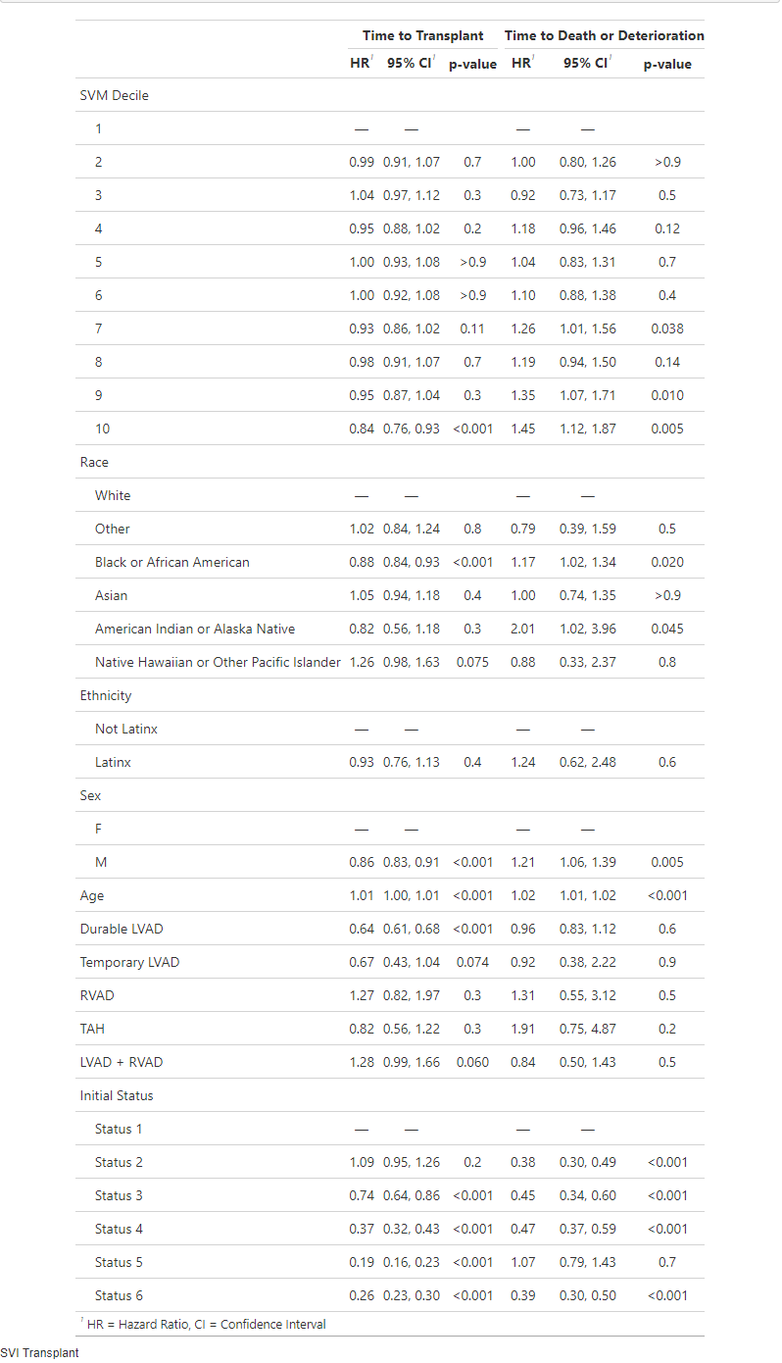

**Supplemental Table 3: Adjusted Competing Risk Regression Hazard Ratios Full Model Results for SVI**

**Supplemental Table 4: Adjusted Competing Risk Regression Hazard Ratios Full Model Results for ADI**

**Supplemental Table 5: Adjusted Competing Risk Regression Hazard Ratios Full Model Results for DCI**

**Supplemental Table 6: Adjusted Competing Risk Regression Stratified by Transplant Center**

|  |  |  |  |  |  |  |  |  |
| --- | --- | --- | --- | --- | --- | --- | --- | --- |
|  | SVM | | SVI | | ADI | | DCI | |
|  | HR | p-value | HR | p-value | HR | p-value | HR | p-value |
| SDoH Composite Score Decile (vs 1) |  |  |  |  |  |  |  |  |
| 2 | 0.95 | 0.16 | **0.85** | **0.047** | 0.99 | 0.86 | 1.07 | 0.12 |
| 3 | 1.03 | 0.47 | **0.80** | **0.005** | 0.99 | 0.82 | **0.91** | **0.048** |
| 4 | 0.95 | 0.23 | **0.77** | **0.001** | 0.92 | 0.16 | 1.00 | 0.94 |
| 5 | 1.00 | 0.99 | **0.78** | **0.002** | 0.92 | 0.16 | 1.03 | 0.59 |
| 6 | 1.00 | 0.99 | **0.80** | **0.007** | 0.96 | 0.53 | 1.02 | 0.69 |
| 7 | 0.96 | 0.34 | **0.78** | **0.002** | 0.89 | 0.05 | 0.96 | 0.35 |
| 8 | 0.98 | 0.58 | **0.82** | **0.015** | 0.94 | 0.33 | 0.97 | 0.54 |
| 9 | 0.97 | 0.49 | **0.79** | **0.006** | **0.86** | **0.025** | 1.02 | 0.63 |
| 10 | 0.90 | 0.068 | **0.79** | **0.035** | 0.86 | 0.079 | 0.97 | 0.60 |
| Age | **1.00** | **<0.001** | **1.01** | **<0.001** | **1.00** | **<0.001** | **1.01** | **<0.001** |
| Male (vs Female) | **0.84** | **<0.001** | **0.84** | **<0.001** | **0.84** | **<0.001** | **0.84** | **<0.001** |
| Race (vs White)  Black  Asian  Native American  Native Hawaiian  Other | **0.92**  1.00  0.77  1.02  0.94 | **0.002**  0.98  0.14  0.89  0.52 | **0.93**  1.02  0.78  1.01  0.96 | **0.004**  0.81  0.17  0.97  0.70 | **0.92**  0.99  0.79  1.00  0.94 | **0.002**  0.92  0.20  0.97  0.51 | **0.91**  1.01  0.78  1.02  0.94 | **0.001**  0.85  0.18  0.92  0.56 |
| Latinx (vs Non-Latinx) | 0.99 | 0.93 | 0.97 | 0.80 | 0.99 | 0.91 | 0.99 | 0.89 |
| Durable LVAD | **0.66** | **<0.001** | **0.66** | **<0.001** | **0.66** | **<0.001** | **0.67** | **<0.001** |
| Temporary LVAD | **0.60** | **0.012** | **0.60** | **0.015** | **0.60** | **0.013** | **0.55** | **0.005** |
| RVAD | 1.46 | 0.059 | 1.48 | 0.063 | 1.46 | 0.062 | **1.54** | **0.04** |
| TAH | 0.77 | 0.16 | 0.76 | 0.14 | 0.77 | 0.16 | 0.78 | 0.20 |
| LVAD+RVAD | 1.25 | 0.14 | 1.27 | 0.12 | 1.24 | 0.15 | 1.26 | 0.16 |
| Initial Status (vs Status 1)  Status 2  Status 3  Status 4  Status 5  Status 6 | 1.15  **0.73**  **0.37**  **0.18**  **0.25** | 0.066  **<0.001**  **<0.001**  **<0.001**  **<0.001** | **1.18**  **0.74**  **0.37**  **0.18**  **0.26** | **0.031**  **<0.001**  **<0.001**  **<0.001**  **<0.001** | 1.14  **0.72**  **0.37**  **0.18**  **0.25** | 0.075  **<0.001**  **<0.001**  **<0.001**  **<0.001** | **1.23**  **0.77**  **0.38**  **0.18**  **0.27** | **0.01**  **0.001**  **<0.001**  **<0.001**  **<0.001** |

*Bolded values represent statistically significant associations

**Supplemental Figure 1: Adjusted Competing Risk Regression** **Hazard Ratios by Place-Based Disadvantage Index Decile**